Chapter 4, Problem 38.

Apply Thevenin’s theorem to find V_{o} in the circuit of Fig. 4.105.

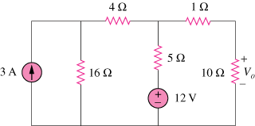

Figure 4.105
For Prob. 4.38.

